Western University Faculty of Engineering

ES 1050 - Foundations of Engineering Practice

Studio Section 13 – Instructor Name

Team Number 6

Friday November 26, 2021

Iteration Report Fall Project

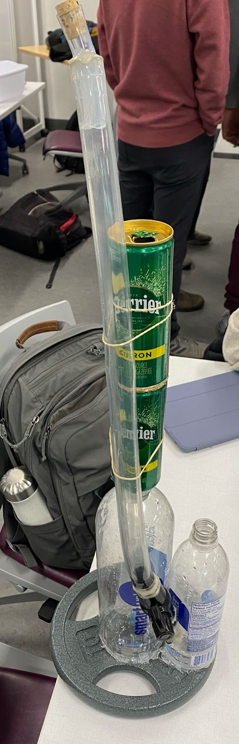

Madeleine Macdonald, Nikhil Arora, Grace Neville, Patrick Woolsey, Jason Adams

# Design Iteration 1:

### 1. Initial Design:

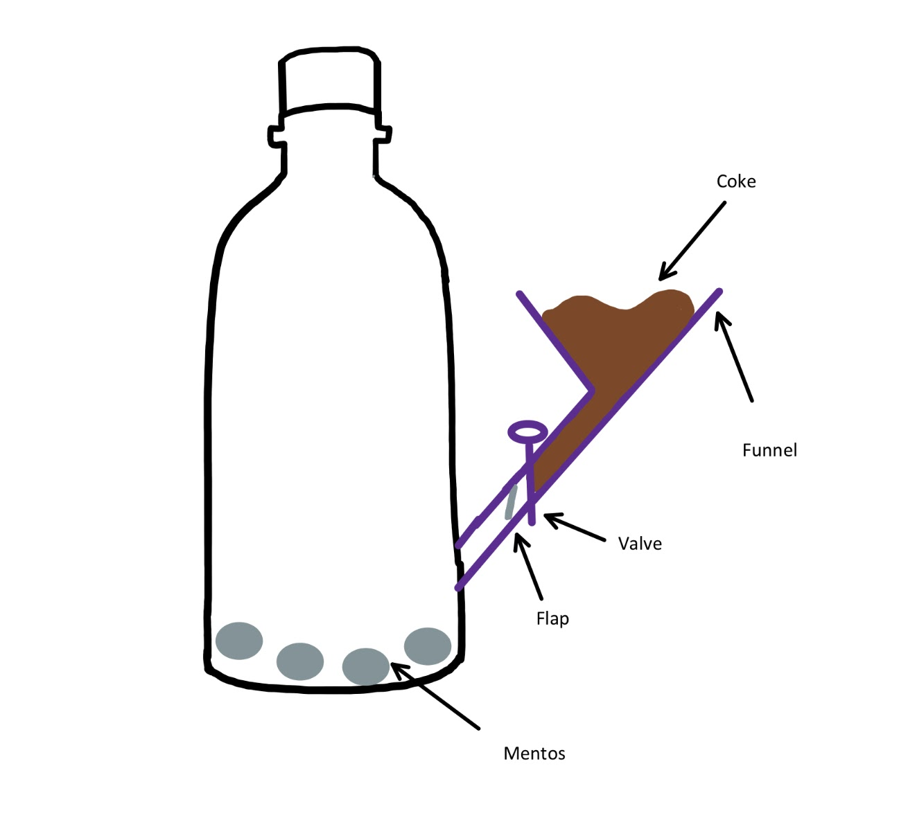

Before the iteration, our group designed a project that consisted of a straight funnel/tube system that would be controlled by a valve and a one-way flap. This initial design was decided with simplicity in mind. The plan was that we would open the valve, allowing the soda to rush into the vessel with the mentos. From there, the one-way flap would prevent pressure from escaping back up the funnel. After much thought and discussion, we realized that we had to reconsider our design.

2. Evaluation of Design:

The current design was evaluated by running unofficial test runs of the reaction (pouring water down the tube to see if it successfully entered the reaction chamber). We at the time had concerns both with how well the liquid would go through the tubing that was wrapped around the bottle, as well as if it would seal properly. During these tests, we had discovered that more often than not, not all of the water would successfully make it to the reaction chamber. This was caused by some kinks in the tubing, causing a clog, as well as an elevation in some areas, due to the tubing not perfectly warping around the bottle, and going up high before going down again in a location. With this, we were also having issues sealing the top funnel, as it provided a large area in which pressure could escape from, though we did not end up doing a full pressure test after this evaluation, before moving on to the next (and currently final) design.

3. Insights on Design:

Like stated above, the tests showed that there was an issue with how reactants were fed to the reaction chamber. This error resulted in both the reactants moving too slowly, and also caused some of the reactants to not successfully make the trip all together.

4. Changes and Solutions for Design:

**Before**  **After**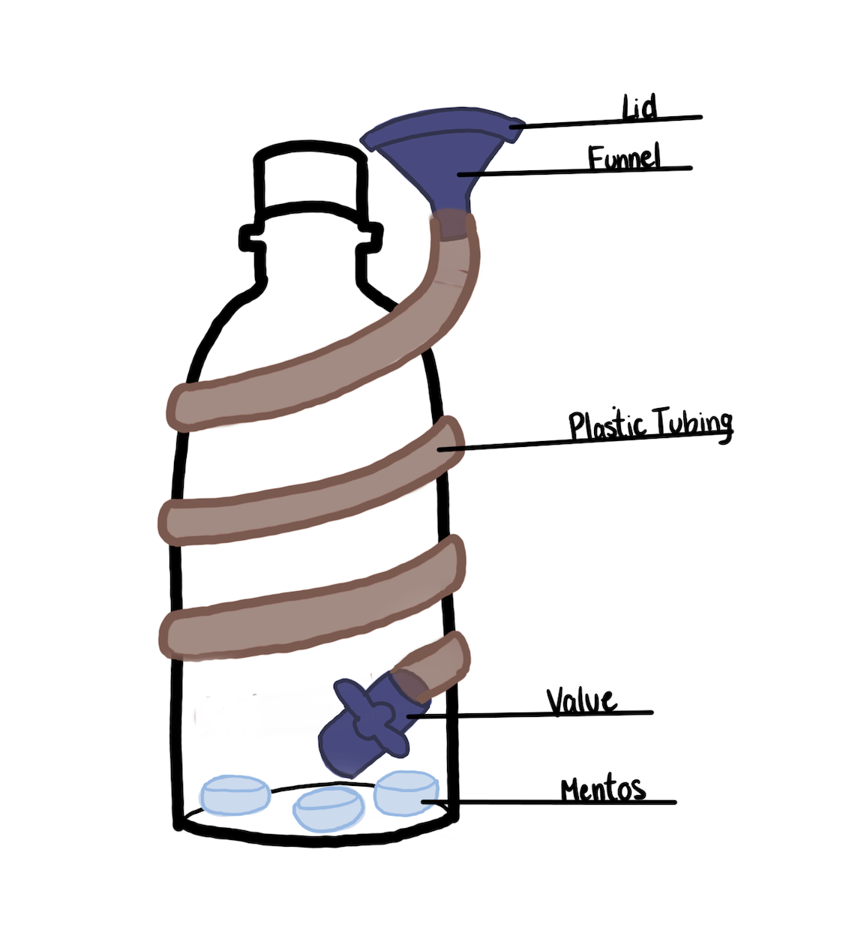

In our updated design we wanted to reduce the number of variables we noticed with our first design.

*This is how we changed the design to account for these issues:*

* Stability Issue
  + Spiralized tubing design allows for the vessel’s centre of gravity to be in the middle of the bottle. Reduces the need for external stability measures.
* Pressure Leakage
  + Airtight funnel lid closes the vessel off from the outside environment. This lid is a more effective and attainable method of preventing pressure leakage than a one-way flap.

Design Iteration 2:

### 1. Initial Design:



From the design structure from Iteration Part 1, our group decided to use a helical tubing mechanism and funnel to pour the liquid into the reaction chamber. Although it’s not depicted in this diagram, we chose to use a smaller vessel than the last design due to concerns of the size affecting the pressure we would achieve with the constraints provided. This design is still controlled by a valve to prevent pressure leakage from the reaction, but will have a lid on top of the funnel to make it a closed system. The valve is attached to the vessel at a slight angle to prevent irregular bends within the helical structure of the tubing around the bottle. This helical tubing mechanism allows for a balanced center of mass between the bottle and liquid without the need for a separate stand for the tubing. This refined design was still designed with simplicity in mind as we felt as though keeping things as simple as possible would lead to a decrease in sources of error. Furthermore, with this design we planned to open the valve, allowing the soda to rush into the vessel with the mentos placed at the bottom of the chamber (being a Smart Water bottle). From there, a lid would be placed on top of the funnel, which is bonded to the tubing using a plastic bonder to prevent pressure from escaping back up and outside the funnel. This lid would be placed onto the funnel after filling up the tubing with the required amount of liquid needed for the reaction. After various reconsiderations and discussions about sources of error which could occur, we realized that there were still changes to be made.

2. Evaluation of Design:

This design was first evaluated experimentally when trying to assemble the system where concerns about how the valve would attach to the vessel, the possible bending of the tubing, and the sealing process using a lid with the funnel became present. Initially, to hold the liquid required in the system, we had to measure the tubing needed to hold the total amount of liquid and cut the tubing accordingly. Along with this, we began measuring how high up the vessel we needed to cut to attach the valve and allow for the liquid to fully enter the reaction chamber when poured. We tested sealing the valve with two different materials (being hot glue and plastic bonder) to see which would be more effective as a sealant for areas of pressure leakage. Furthermore, we tried to attach the measured tubing to the bottle where unofficial test runs of the reaction were done to test these sources of error. After assembling, a problem arose where the valve continued to hit the vessel when turning it to open and close. This resulted in an inability to begin the reaction and pour liquid into the bottle. Similarly, we tried to attach this valve to the structure in a way to create an airtight seal which would keep the structure of the helical tubing without any form of irregularity by bonding the valve and vessel together. From other external feedback we received from both peers and instructors, it was also brought to our attention that pressure could potentially leak up the tube leading to a larger vessel volume and lower overall pressure, making it harder to reach our desired pressure.We tried performing the reaction test to see if any pressure leakage would be a result from the bonding of the valve and vessel. We also tested the balance of the overall structure to see if the chamber and tubing could maintain its balance on its own when a reaction occurred. Finally, we continued our experiment analysis and tried to bond the funnel to the tubing with the closed lid to prevent sources of pressure leakage when performing the reaction.

3. Insights on Design:

After performing these experiments, we found various sources of error which occurred in our assembly process which would result in refining our current ideas. Our first main source of error was our sealing material used, as we found that hot glue was not effective in sealing our parts so we decided to use plastic bonder for all areas of sealing required due to its ability to withstand high amounts of pressure. Furthermore, when trying to attach the valve at the required angle to maintain the helical structure of the tubing, there was unevenness in the connection between the hole and valve. This made it much harder to seal effectively with the plastic bonder resulting in forms of pressure leakage during our unofficial testing phases. Similarly, the valve had difficulty turning correctly due to the way it was required to be inserted into the bottle. With the attempt of trying to maintain balance with a helical shape for our tubing, we found it caused irregular defects and kinks resulting in an inconsistent flow of liquid. Also, with the amount of liquid we required to use and the balance test we performed, we found that the helical shape stretched beyond the size of the bottle we were using, resulting in an imbalance of mass of our overall structure. From the external feedback received, we also found that with leaving the valve open pressure was able to travel up the tube resulting in a dispersion of the pressure throughout the larger volume, making it harder to reach our desired PSI. Finally, when trying to attach the funnel and closed lid to the tubing we were not able to bond them together as the weight of the funnel was too heavy for the tubing to hold straight up and maintain its structure.

4. State the design change or solution the team developed to address the challenge or leverage the insight and what the team expects that change to achieve and thus show the change was made with considered intent. (e.g. apply XXXX at YYYY to seal the leak, or deploy two feed mechanisms to double the maximum possible feed rate).

o This should involve captioned **figures** (i.e. diagrams, images, specifications and or drawings) to fully illustrate how the design evolved during this Iteration.

o Changes can be presented either through before and after illustrations or through single illustrations with annotations clarifying the changes made (or through other equally effective way to convey the same information)

4. Changes and Solutions to Design:

**Before**  **After**

 

In our final design we wanted to reduce the number of variables we noticed with our first refined design.

*This is how we changed the design to account for these issues:*

* Bonding Material
  + Plastic bonder to be used as our bonding material over hot glue as it has a higher pressure capacity and works effeciently for the materials we are using for our vessel and valve (both being plastic).(can be seen in the after image to seal top tubing to valve)